In this lesson we are going to use tracker node to do stabilization on video footage . In the last lesson we learned about tracker. In this lesson we will be doing stabilization we will go to pixabay as we have previously gone there and we will find some footage that’s kind of shaky so that we can stabilize it so we search video about bike the video we did choose for previous lesson was made by tripod. Its all nice and stabilised already but if we hover

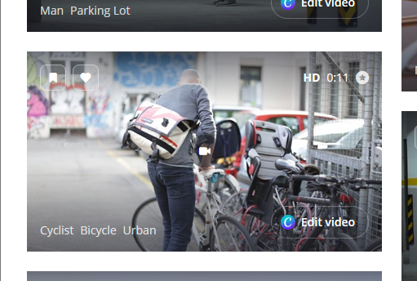

We will choose above video as it is shaky and there is camera movement involved so it is a great one to practise some image stabilization on (who knows) Now we click on it to open it

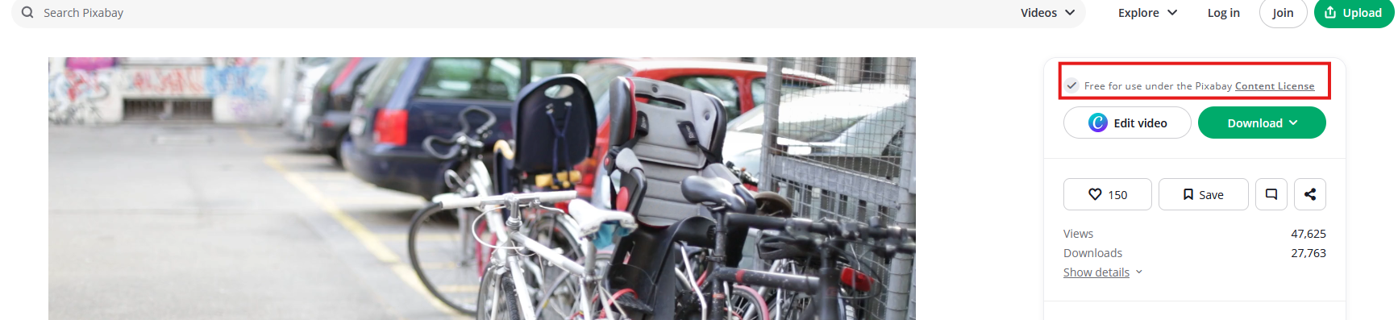

Now from above we can see from marked above that that this video is copyrightfree and free to use

So we download the video of 1920 X 1080 resolution as marked below

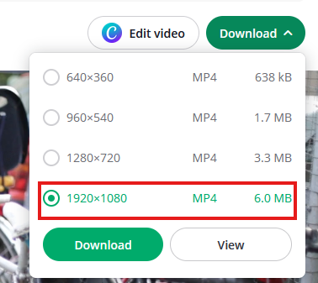

Click on download button below the marked

Now go to its downloaded location and then drag the video from the folder to the node graph so the read node related to it is formed as illustrated below

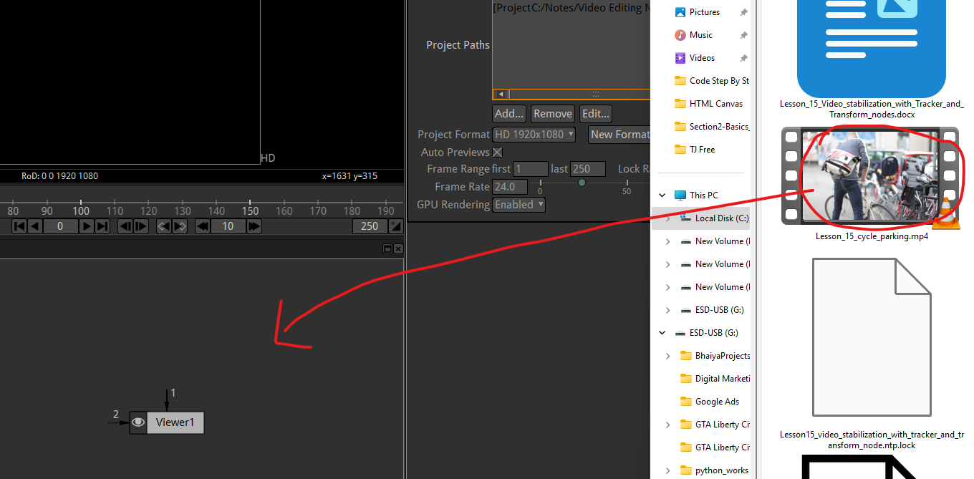

Now there will be a read node in the node graph as shown below

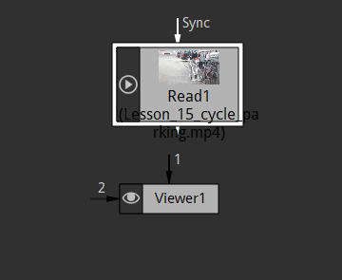

Connect them and Now in viewer node you have your video as shown below

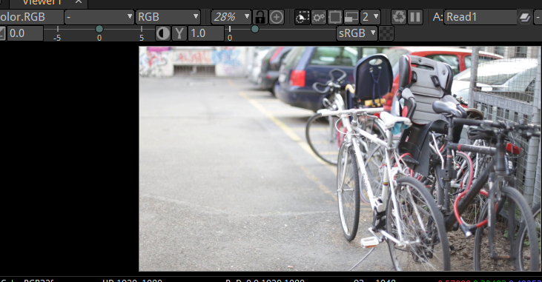

Now we can play it and view it in natron and we are gonna stabilise the first 50 frame so I go down my project settings panel and change the frame range here it make the last field from 272 to 50 as marked below

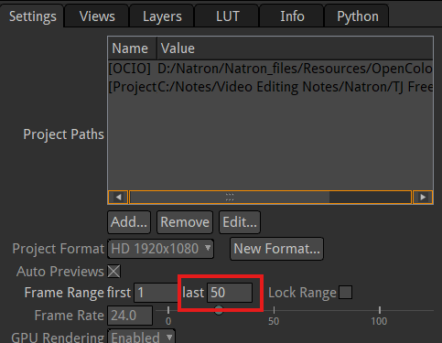

Now our we have frame 1 to 50 and then

Now we see that frame rate in the read node (that is of video ) is somewhat 25 but the frame rate in project 24 frame per second we will make the frame rate project 25 as shown below so that both video frame rate and project rate remains the same

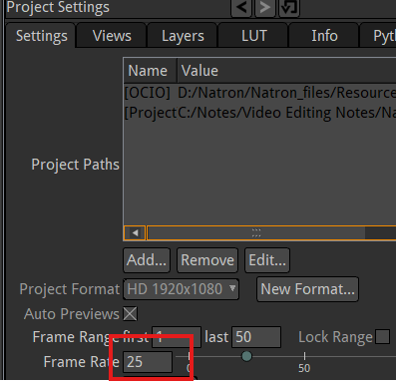

Since we are doing just doing a single video file that will be good now we play this and it will play through 1 to 50 frames and then keep looping through it as shown below

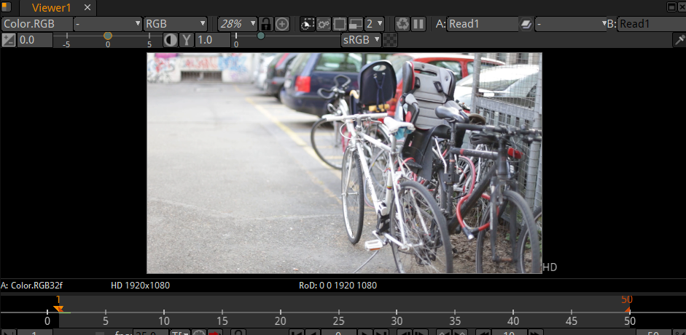

drag on the bottom edge of the viewer to increase its size vertically so we can look it properly as shown below

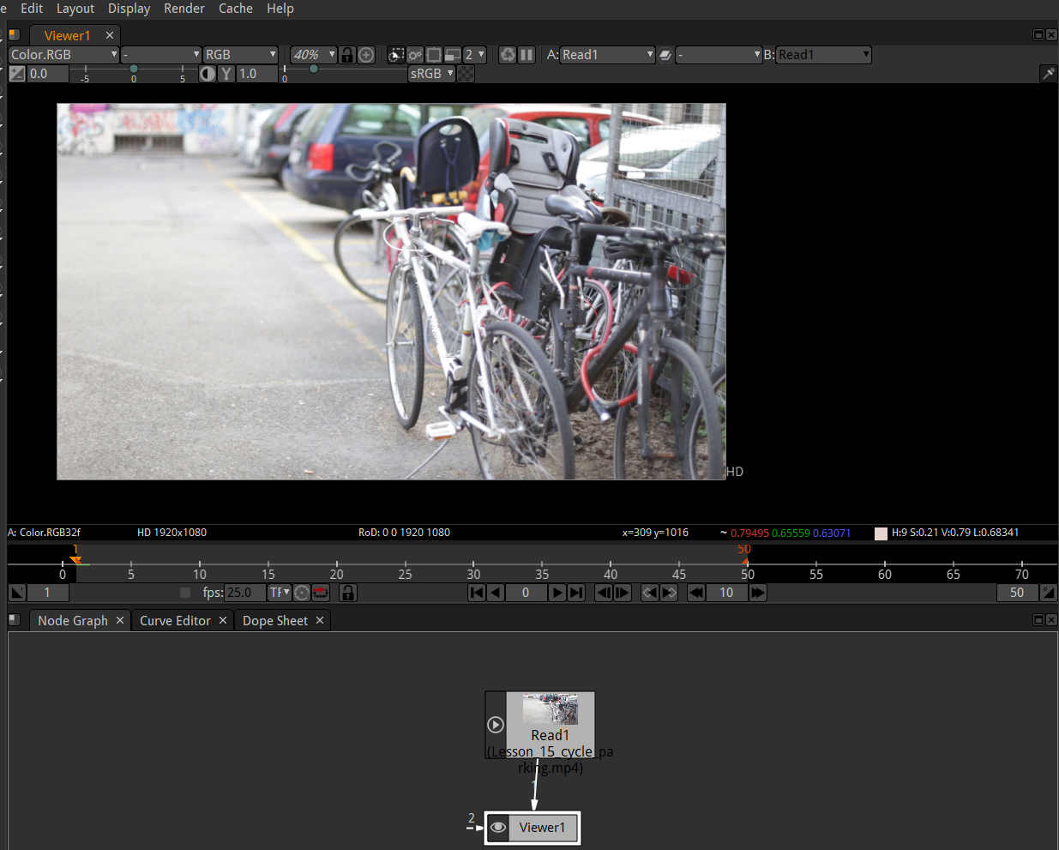

Now we add tracker node to our node graph

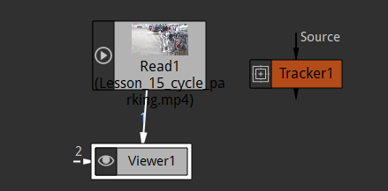

Now you can see above we have tracker here and then we want to automatically track we could choose point if you remember we can manually track frame by frame but we will do it automatically you know

I connect tracker in between the Read and viewer node so that tracking property is added to out video Now our node graph will look like below

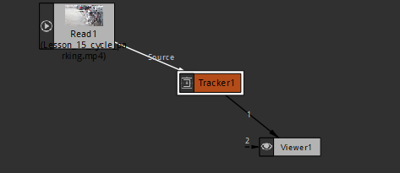

Before we add this tracker we watch our video couple of times Teacher don’t want to pick up a point that stays kind of stable and its very clear that the natron will be able to automatically track and follow (who knows maybe talking about the ability of natron to track points in stable video)

Teacher watch it for some point and see if Teacher can find a point He don’t want to select a point where the person in the video walking through in front of handle bar (as marked 1 below) or the car (as marked 2 below)

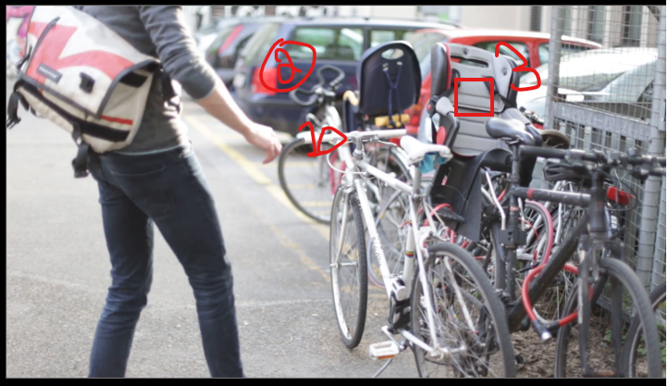

Because he walks in front of tracking point

3:25

But there is point on bike suit as marked 3 above that don’t get covered up throughout the whole video So we will choose this point

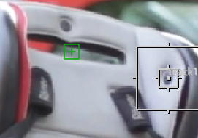

We will zoom into the seat and choose the tracking point by add tracker tool in the viewer panel Now after adding it , it will look like above

So we can see what natron can see to track off as marked below

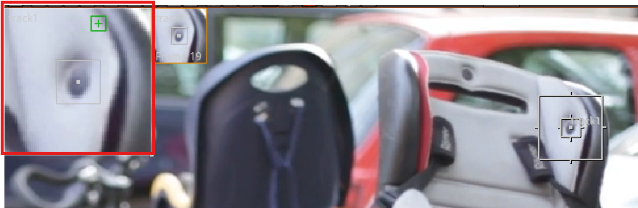

Now we will expand the outer part of tracker point as shown below so that

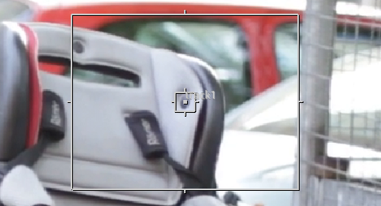

we can track that point there we have track 1 in our track list in the property of the tracker properties as marked below

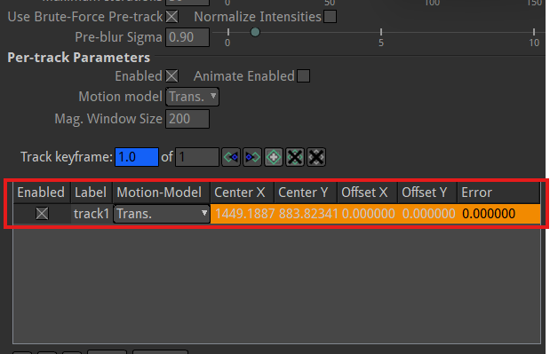

we are on frame 1. Now we click on the marked below button in viewer panel

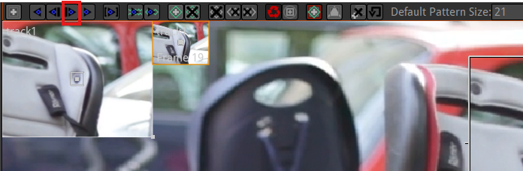

Now you track the position of that in next frame as you can it barely did it (because point has moved less in the between both the frame) and a little line will be there to show the transition of the point position between the frames as marked below

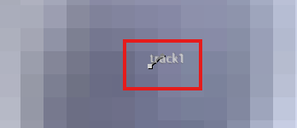

The line us small that we have to zoom it

Now click on the marked below button(that is track forward) in viewer window

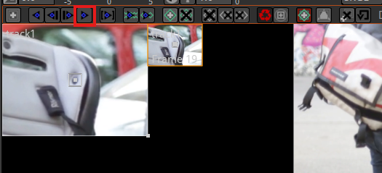

This will make a track points may to the end of all the frames of the videos as marked below

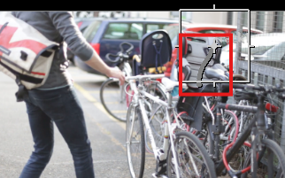

This track forward through everything so this is the fast because its only 50 frames

Now we will play the video then this grey line( marked above ) with lots of point for every frame and it is tracking the point properly you zoom in and see the track line constitute of track points following the point we chosen in seat for tracking

Okay Teacher forget to say that but the type of tracking that I have on is just on translate as marked below in the track layer

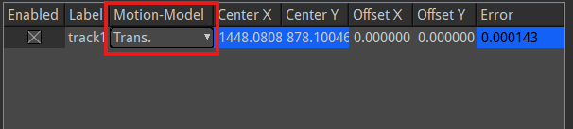

now which is basically looking at how the video moves like up and down, left and right what it is not looking at is rotation(who knows according to the teacher ) so how it moves rotating like clock wise and counter clockwise and also it is not looking zoom in and zoom out Its not looking for changers in zooming (who knows(maybe he means trans + scale in motion -model)) It is just looking left and right , up and down or looking at any type of movements in the video

this way if that makes sense but we can change that we can say we want you to track rotation as well as scaling(or zooming and zooming out) in the video we can do so by choosing the option suitable for such movements shown in the motion model as shown below

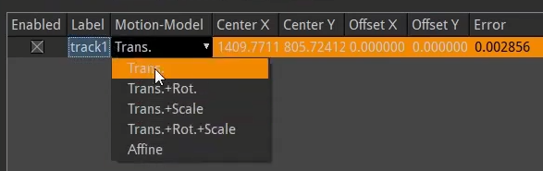

Teacher says there is no any rotation in the video(who knows) we can choose other transform operation but we choose translate as there is no rotation and scale(zoom) in the video

Now in tracker properties go to the transform tab and we can see option for this as shown below

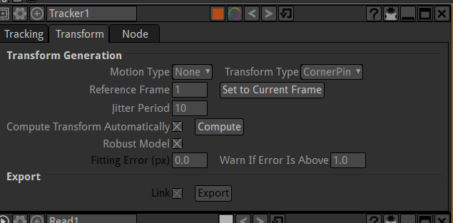

So right now our option so right now motion type is set to none so we can’t export any of the data from this tracker because our motion type is none

We can do match move is what we did in the last lesson where we tracked an object across moving object in a stable setting this time we will choose stabilize as highlighted below in the motiontype so we stabilize all the footage in general

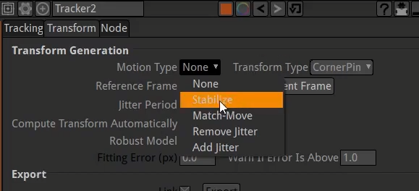

We are not trying to you know track a certain object necessarily so we have that stabilised and then transform type

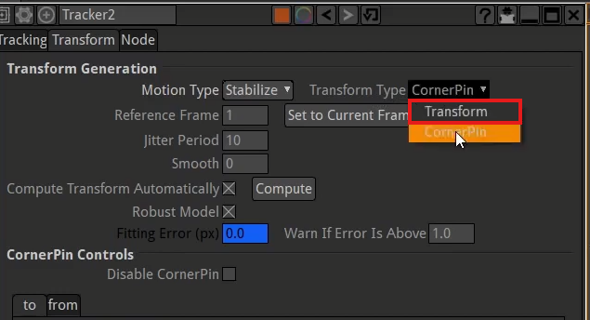

We are not gonna use corner pin because we just want the video footage to move in viewer window move such that in each frame the video footage point that is chosen for tracking is moved to match the first track point in the video so due to which I think that when track point is moving downward frame by frame then the footage will move upward so that when we zoom in that point then it will look stable in our case the seat looks stable ( I think by corner points the video footage will shake (who knows))

Okay so we are just stabilizing the footage so when we set motion type as Stabilize and Transform type is set to Transform

Now below this all in Transform controls section in Tracker properties as marked below

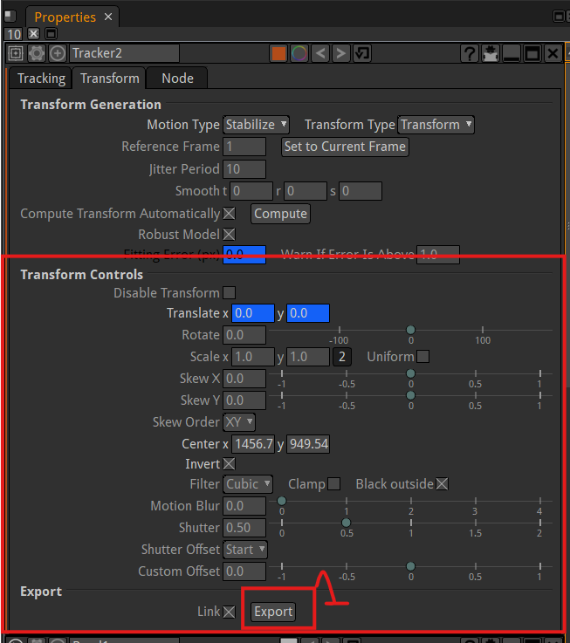

Now in marked above you can see the keyframe is set for Translate operation and so we can so if we look through here that frame by frame the position of video footage is changing so that It looks stable

Now we click on export marked as 1 above

Now we get the data for this in a transform node as shown in the marked below

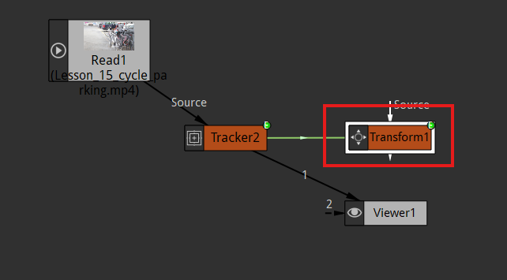

We double click on this transform node to show its properties Now you can see this transform already has keyframe node as marked below

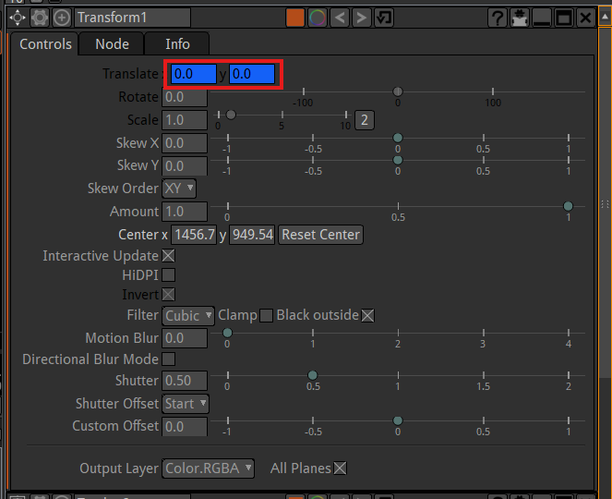

and if we move forward it’s changing, it’s moving whatever we put in our transform it is moving the object connected to it. Now to show us an example maybe that the transform has keyframe so we disable out video and just delete the tracker

and add a color wheel here and then make it source of the transform node so you can see below

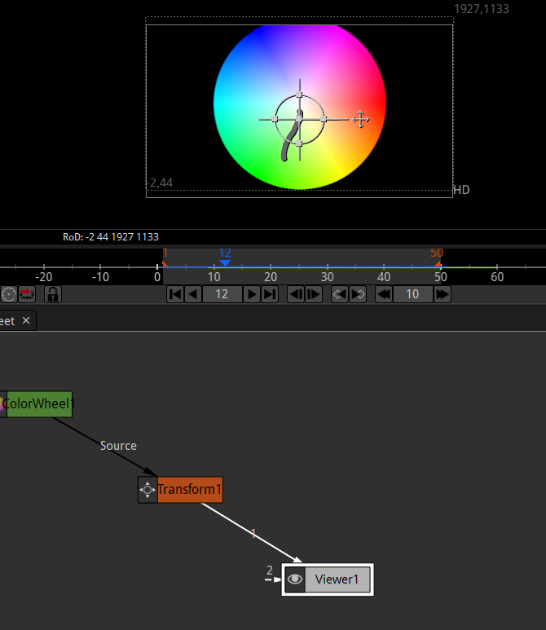

So now colorwheel now move according to the data stored in transform node that was extracted from tracker node Now the color wheel move as shown below

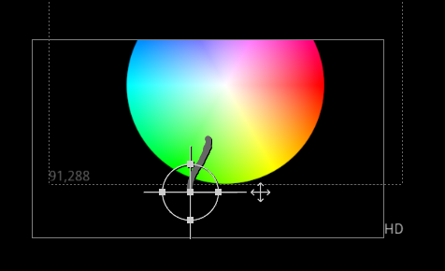

So we have illustrated that we have created a track that we can map an object to but instead of color wheel we just delete it and enable the shaking video footage

So now our video will be moved according to the transform node and the information of these nodes are based on the video that creates a nice stabilising effect

Now you will play the video now it will look that everything is stable and nothing move

And now we compare the new footage to the old footage before tracker was added to the footage

9:50

Si we press tab and then in temporary search panel we type viewer and then press enter and then a second viewer node is shown in our node graph as marked below

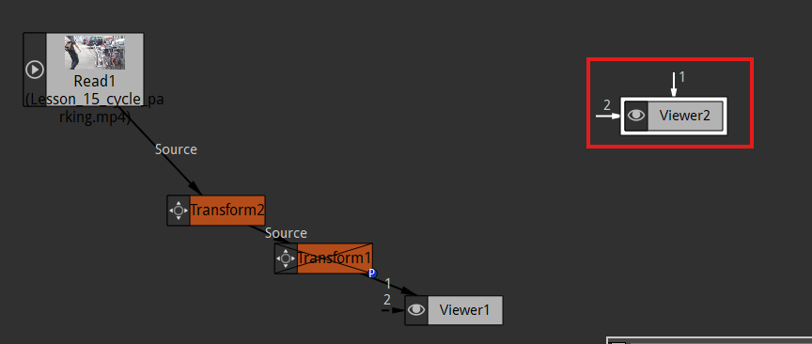

Nowe you will see there is another tab in our viewer panel as marked below that is representing the output that viewer 2 is getting as marked above

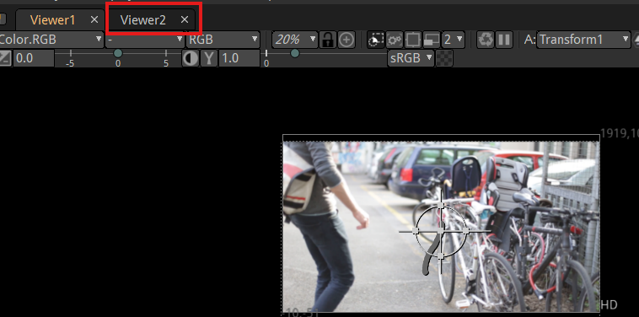

And now connect out viewer2 node to footage node as marked below

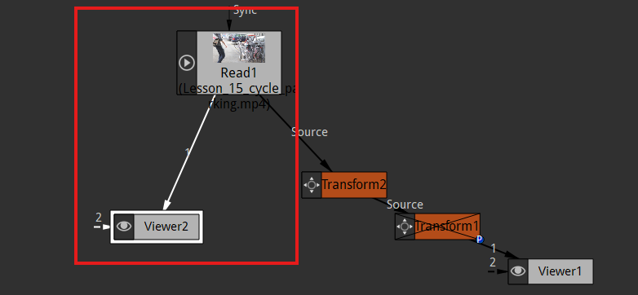

Now we discovered new things that if we drag a tab and then if you hover over any part of the UI and if it could fit there then that place will be highlighted by dotted boundaries as marked below

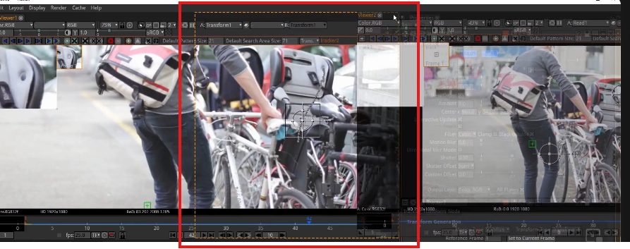

Now we drag and drop it in the similar manner as the teacher. Now our UI will look like below

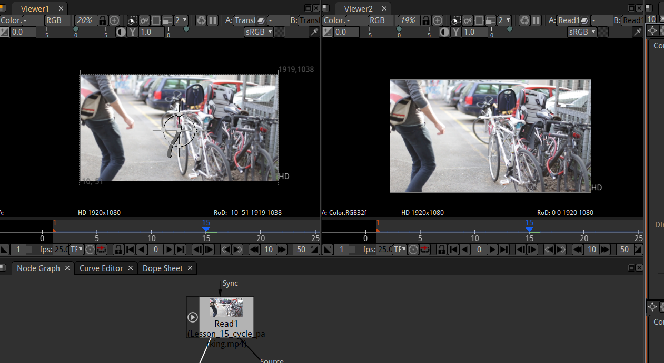

So now we have viewer1 and viewer2 side by side. as shown above

Now one thing you notice is that in the timeline controls of any viewer tab of you click on any button whether it is play and next frame etc it will work on both the viewer tab. So we click on first frame as marked below

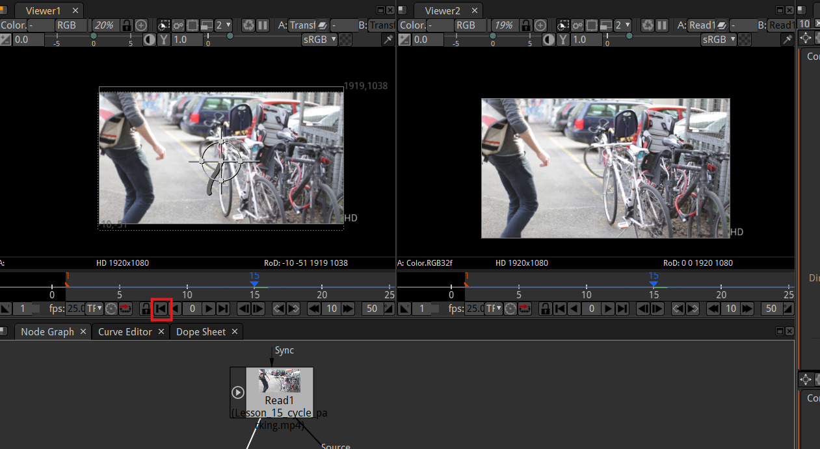

to reach the first frame now you will be in first frame in both the tab

Now if we zoom in the bike seat on both the frame as shown below

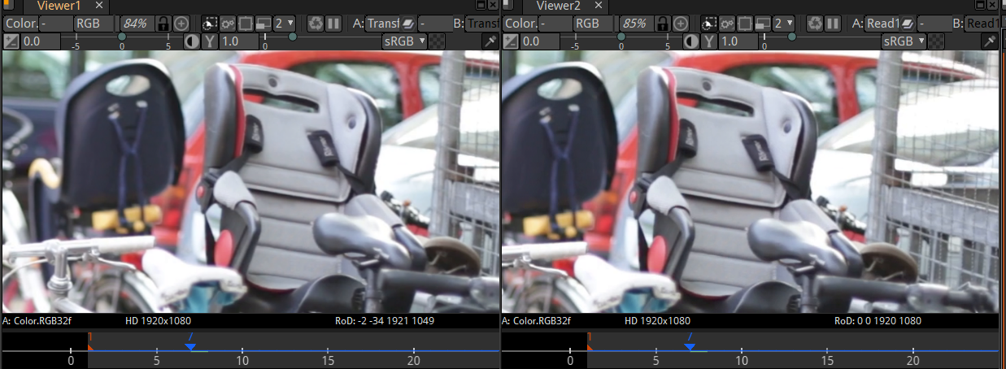

Now you will see that Viewer 2 is kind of shaky and viewer 1 is not shaky and nice. And we would have to crop that in too so because what this is really doing we close the viewer2 tab

If we were to export this from viewer1 node then we would see a black section in the video as marked below

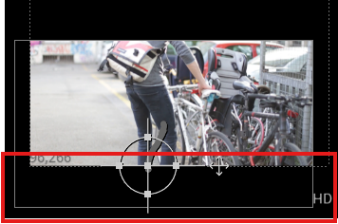

As you can see above that in video there left blank area as shown above. This video footage is moving up to counter video sliding down and make the video stable die to which it is leaving black spaces So we need to do in addition is to apply a crop so we would want to like if we hit tab then search tab appears and type crop and then press enter button now there will be crop node in node graph as shown below

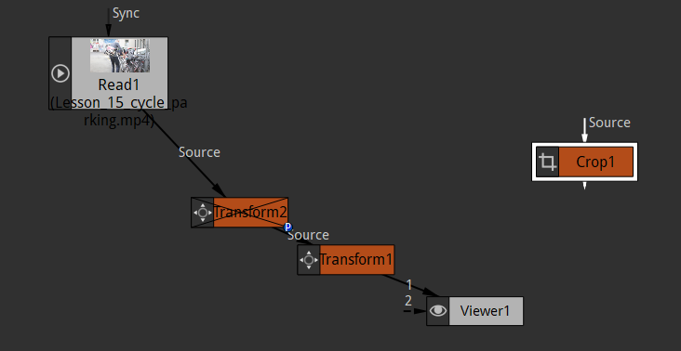

You can also get it by go to transform tools as marked below in toolbar and then in submenu click on crop option as highlighted below

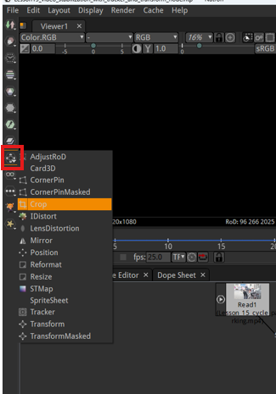

Now drag and drop the crop node in between tracker node and viewer node as shown below

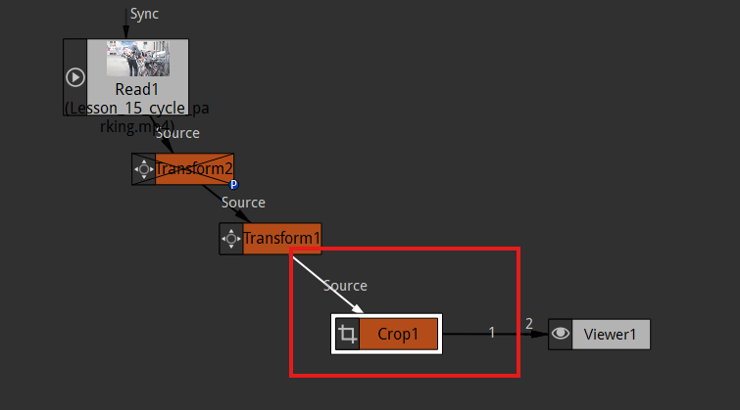

Now after adding crop in between Transform and Viewer node the footage will be surrounded by the thick edges as shown below

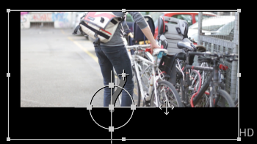

So we can just crop this by manipulating the hard edges you see above (as the area inside it will be visible and outside it will not be visible)

You can go to crop properties in properties window

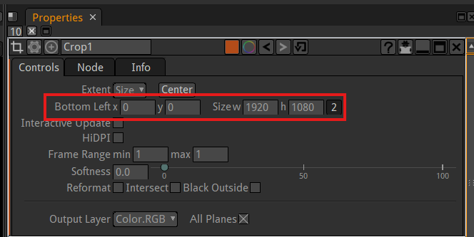

and then in marked above you can set its location which from bottom left and can also increase and decrease the size of the crop rectangle (I name it).

or we can just drag it along the edges in viewer window to modify it as shown below

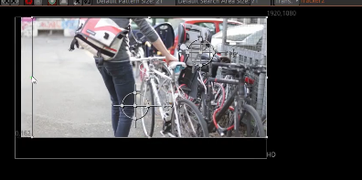

So now we have just cropped our video as shown below

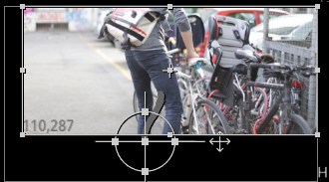

So we are just seeing above part even it actually comes up the video will look it is not moving up but a stable video

11:50

so what we need to do is scale video Footage so we add a transform node after the crop so that the crop window and footage get scaled together So we add it now our node graph will look like below

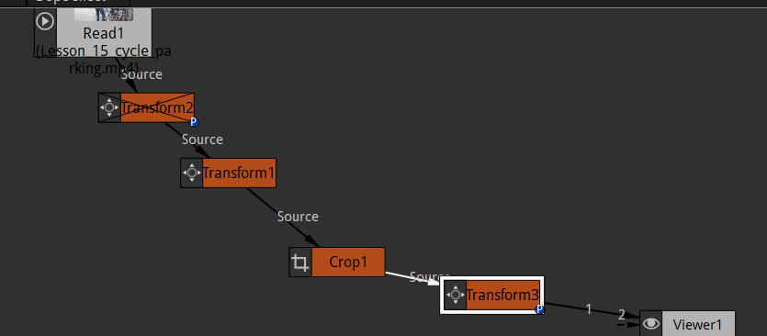

So now we can transform this crop and footage together so we scale this by going to transform3 properties

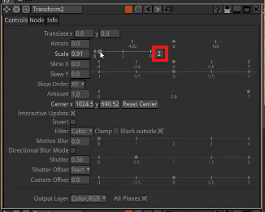

You can scale your footage from transform2 properties as shown above if you click on the marked above to toggle between even scaling and scaling in x and y direction

We scale the footage and crop until it covers the whole visible screen as shown below

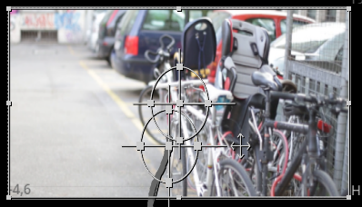

We can see it is nice and stable. A very stable video That was very basic video stabilization using a tracker we just used one tracking point on our tracker

If we choose motion mode as Trans + Rot we need two tracking points(who knows) on each frame because if its rotating like 90 degrees or rotating towards right you need second point to tell what that rotation is and same with scaling you need second point so that you can compare the two and tell that if its scaling in and scaling output So that’s using the tracker node to create video stabilisation in Natron.